Coach User Documentation

Contents

Login 2

Menu 3

Add Player 4

Edit Player 6

My Squad 9

View/Edit Squad 10

# Login

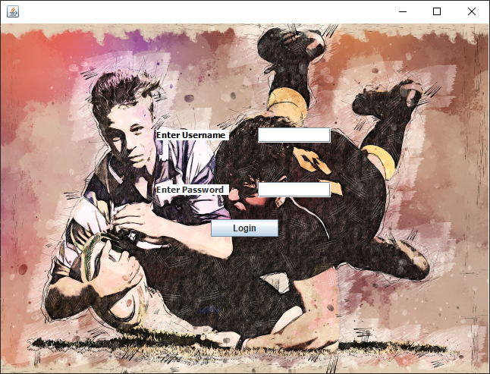

This is the login screen where you will enter your username and password e.g. username: th1 password: coach1. If you click login and either of the text boxes are left empty or the username and password are not connected, an error message will display.

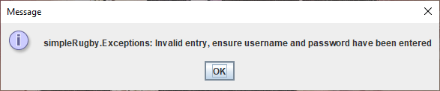

If 4 or more attempts are made to login with missing or invalid information, you will be told that too many attempts have been made and the app will close.

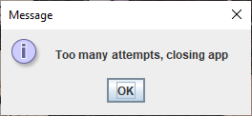

If username and password match for the account you are accessing, you will be taken to the menu. As the account you are accessing is a coach account, you will be displayed with the coach menu.

# Menu

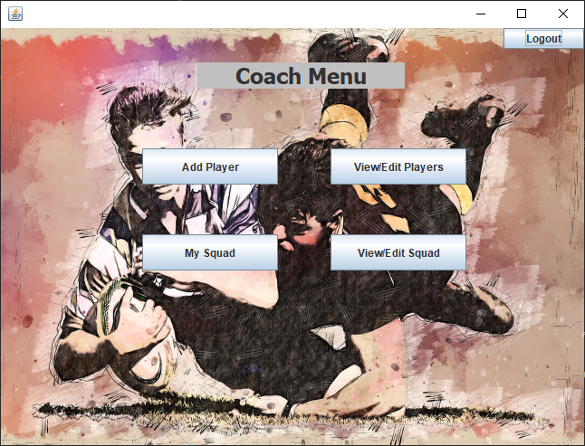

This is the coach menu with 5 buttons that can be clicked. If you click logout, you will be logged out and returned to the login screen. You will be required to login again to get back to the menu. If you click add player, you will be taken to the add player screen to add players to the app. If you click view/edit players, you will be taken to the edit player screen where you can edit or delete players. If you click my squad, you will be taken to my squad screen to view your squad and the players in it. If you click view/edit squad, you will be taken to the edit squad screen where you can add or remove players from your squad. If you are not the coach of a squad, you will not have access to my squad or view/edit squad and will be shown a message advising you to ask an admin to add you to a squad.

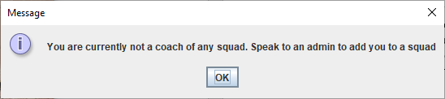

# Add Player

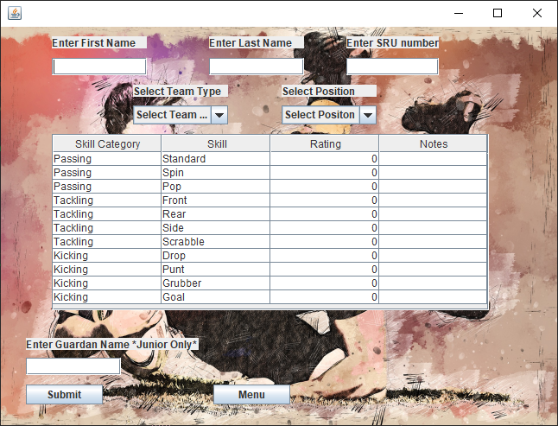

This is the add player screen. This can be used to add players the are seniors or juniors. If you click the menu button, you will be taken back to the menu. You will enter the first name, last name, a 6 digit number for the SRU number that does not start with a 0, select the team type of the player (senior or junior) and select position from all the positions that a rugby player can have on the field and click submit. If the player is a junior you will also need to enter a guardian name. It is optional but you can set the ratings and notes for each skill for the player you are adding, if not these will be added as ratings of 0 and blank notes to be set later. If you are adding a senior player and leave first name, last name, SRU number, team type or position blank, you will be shown a message saying these need to be entered when you click submit and the player will not be added.

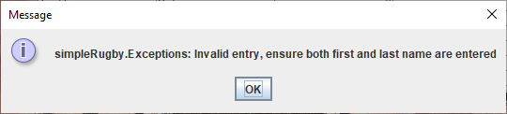

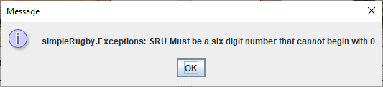

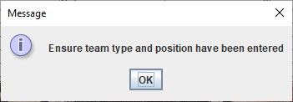

If these are all entered and valid, you will be shown a message saying player has been added and taken back to the menu. You will need to click on add player to be able to add another.

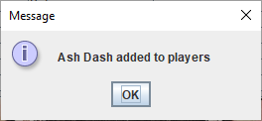

An error message will display if you attempt to add a junior player and do not enter a guardian name

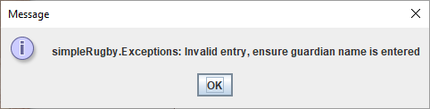

If a guardian name is entered, you will be shown a message saying the junior player has been added and taken back to the menu. You will need to click on add player to be able to add another.

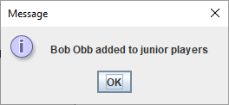

# Edit Player

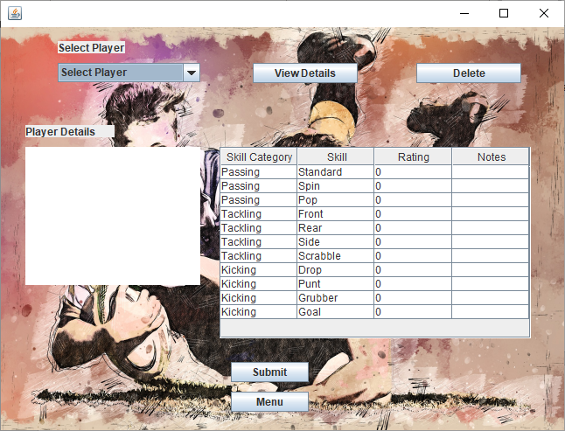

This is the edit player screen. It will be used to select a player, edit their skill ratings and notes or delete player. If you click the menu button, you will be taken back to the menu. If you click view details or delete without first selecting a player, nothing will happen. If you click submit without selecting a player, you will be shown a message requesting you select a player and click view player before clicking submit.

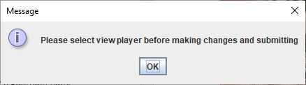

Once you select a player and click view player, you will be shown information on the player in the player details box and the table will change to the player’s set skill ratings and notes. You can change the ratings and notes for each of the players skills by entering them into the table and clicking submit.

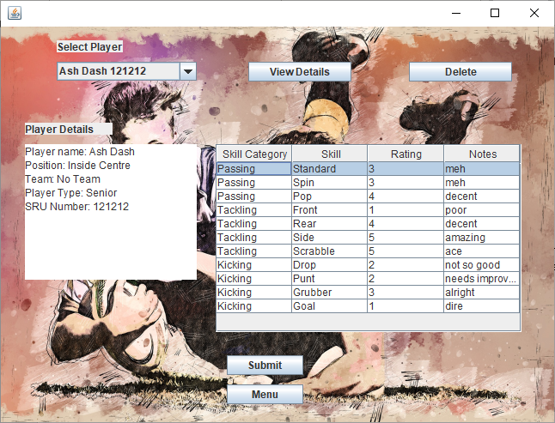

If you wish to delete the player, you will be asked to confirm you wish to delete the player. If you click no or cancel, the player will not be deleted. If you click yes, the player will be removed from the app and you will be taken back to the menu.

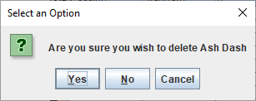

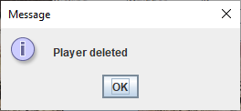

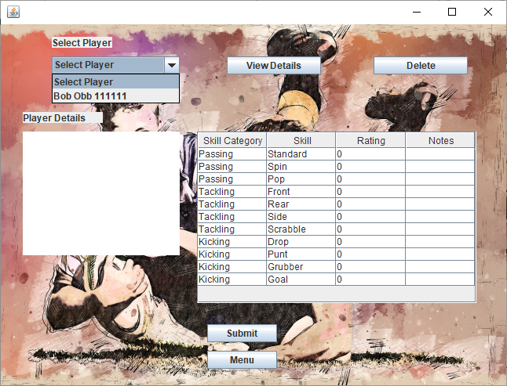

This shows that the player is no longer in the system. If the player was in any team, they will no longer be present in the team or the selection of players to be added or removed. If you select view details on a player then select another player and change information, click submit or delete without clicking view details, you should be shown a message requiring you to ensure that you have clicked view details. This is to stop you from accidentally editing or deleting the wrong person.

# My Squad

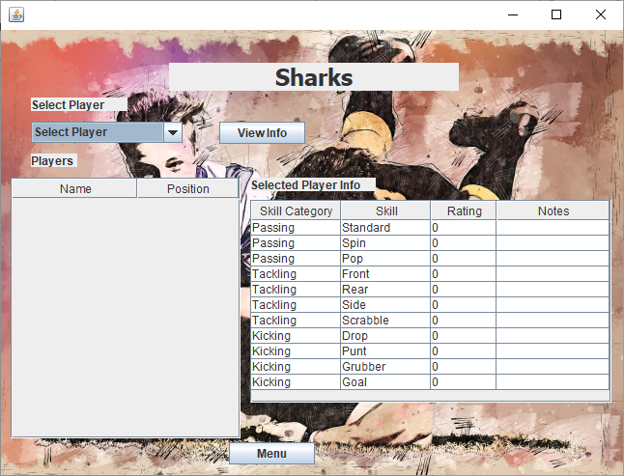

This is my squad screen. It will show all the players in the squad and their position on the table to the left and you can select a player and click view info to have that player’s skill ratings and notes displayed on the table to the right. If you click the menu button, you will be taken back to the menu. If it is empty, there is no one in the squad yet and you will need to go to view/edit my squad to add players to the squad. If there are players there that should not be, you will need to go to view/edit my squad to remove them from the squad.

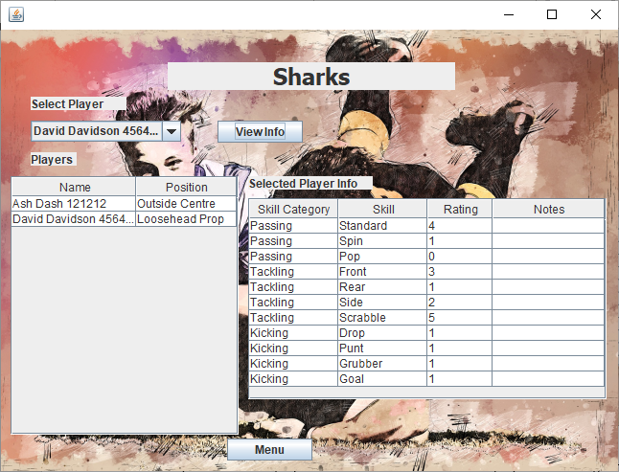

This is what my squad would look like with 2 players and if you select a player and click view info.

# View/Edit Squad

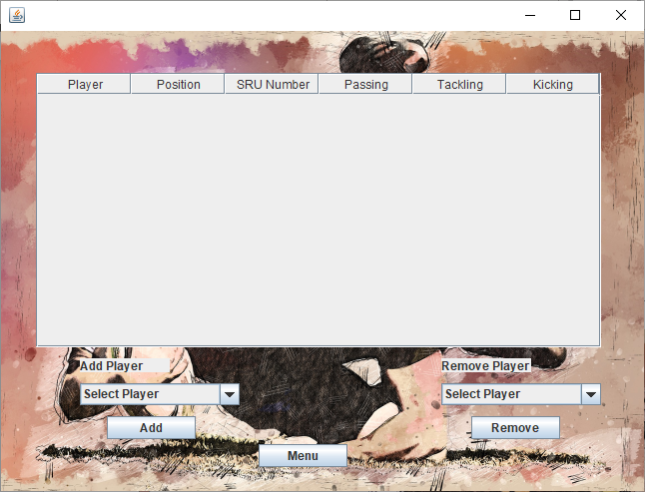

The is the view/edit squad screen. It will show all players in your squad, their position, SRU number, and average passing, tackling, and kicking skill ratings. If you click the menu button, you will be taken back to the menu. If there is no one in the squad, it will be empty and you will need to select a player from add players and click add to add them to your squad. You will only be able to select from players of the same team type as your team e.g. senior players for a senior team. Once you have added a player, you will be shown a player added to squad message and taken back to menu. If you wish to add another you will need to go back into view/edit squad.

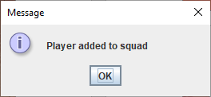

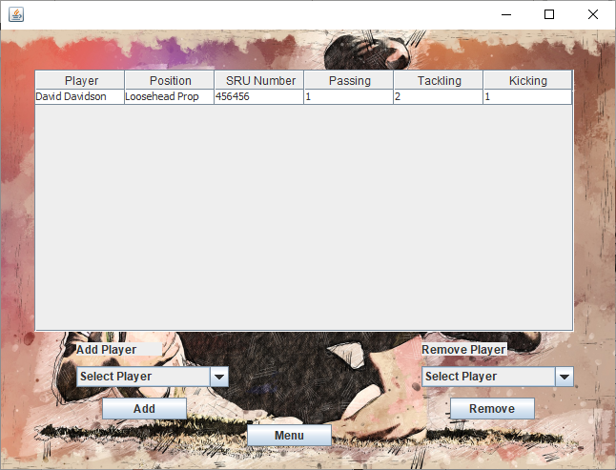

If you wish to remove a player in your squad, you will need to select the player from the list of player in your squad. You will be asked to confirm this and if you click yes, the player will be removed from the squad but will still be in the system to be added back to the squad or added to another squad of the same level.

